Problem 2 – Sprint Planning
Environment Specifics
Please be aware that every JS environment may behave differently when executing code. Certain things that work in the browser are not supported in Node.js, which is the environment used by Judge.
The following actions are NOT supported:
- .forEach() with NodeList (returned by querySelector() and querySelectorAll())
- .forEach() with HTMLCollection (returned by getElementsByClassName() and element.children)
- using the spread-operator (...) to convert a NodeList into an array
- append() (use only appendChild())
- prepend()
- replaceWith()
- replaceAll()
- closest()
- replaceChildren()
If you want to perform these operations, you may use Array.from() to first convert the collection into an array.
Use the provided skeleton to solve this problem.
Write the missing JavaScript code to plan your next two-week Sprint:
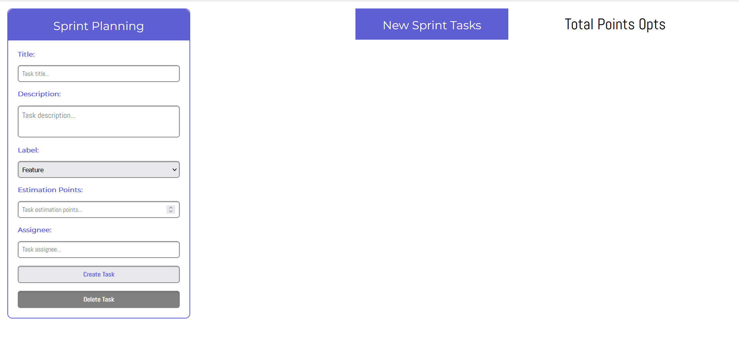

Create a Task
- You're provided with a form that contains the following fields: Title, Description, Label (a select field with 3 options), Estimation Points, Assignee, and two buttons – [Create Task] and [Delete Task]. After the page initialization, the [Delete Task] button is disabled.
- After the user successfully fills out all of the fields and clicks on [Create Task] button, it should create a new article inside the <section> with id "tasks-section".
- That article has the following HTML structure (be careful when you create it and add all of the necessary HTML elements and attributes):
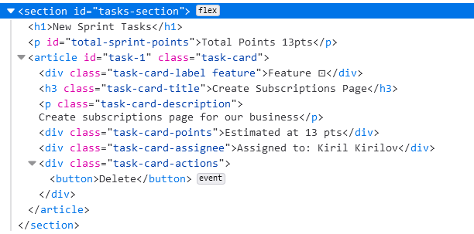
- You have to fill out ALL of the input fields, otherwise clicking on the [Create Task] button shouldn't do anything!
- The <div> with class "task-card-label" has different HTML code icons next to its name depending on whether it is a feature, low priority bug, or high priority bug. Here are the HTML code variations:
  - Feature: &#8865;
  - Low Priority Bug: &#9737;
  - High Priority Bug: &#9888;
- The label <div> also has an additional class that styles it differently, so be sure to add it:
  - feature: "feature"
  - low priority bug: "low-priority"
  - high priority bug: "high-priority"
- Each task should also have an id attached to the <article>, which you have to generate in the following format: "task-1", "task-2", "task-3" etc. You will need that later!
- Successful creation of a new task should also clear all of the input fields!
- An example with all 3 types of tasks:
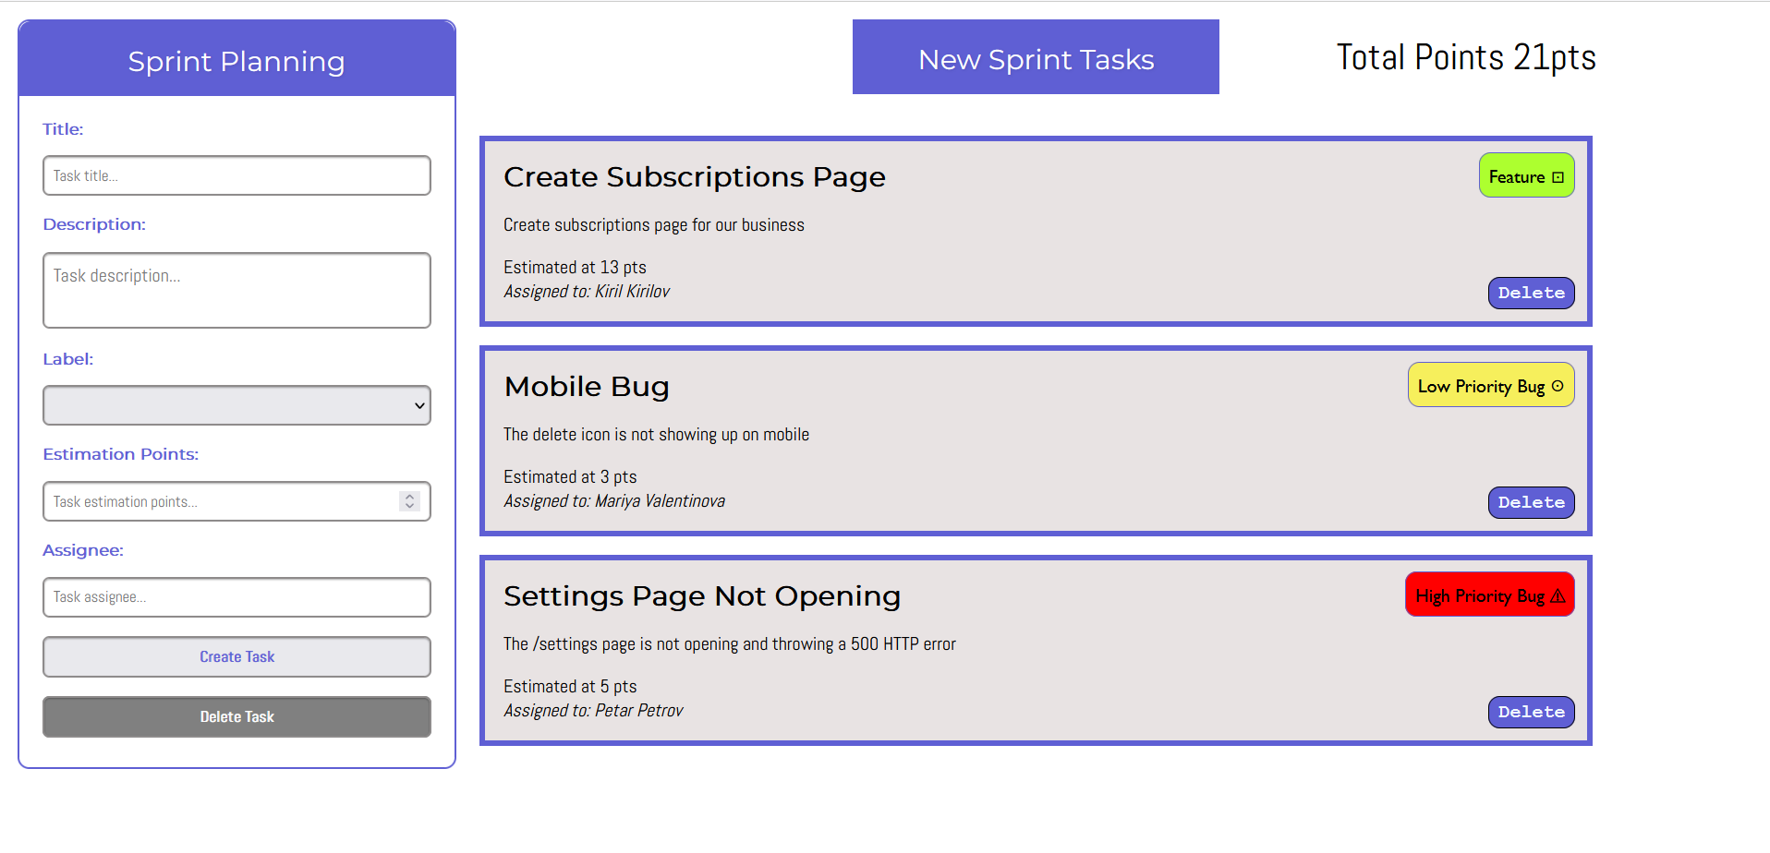

Load Confirm Delete
- Clicking on the [Delete] button on the bottom right corner of a task should load all of the information of the current task in the form on the left.
- This action should enable the [Delete Task] button on the form and also disable the [Create Task] button
- It should also make all of the inputs disabled!
- There is an <input> of type "hidden" in the form where you should store the task ID you generated when you created the task.
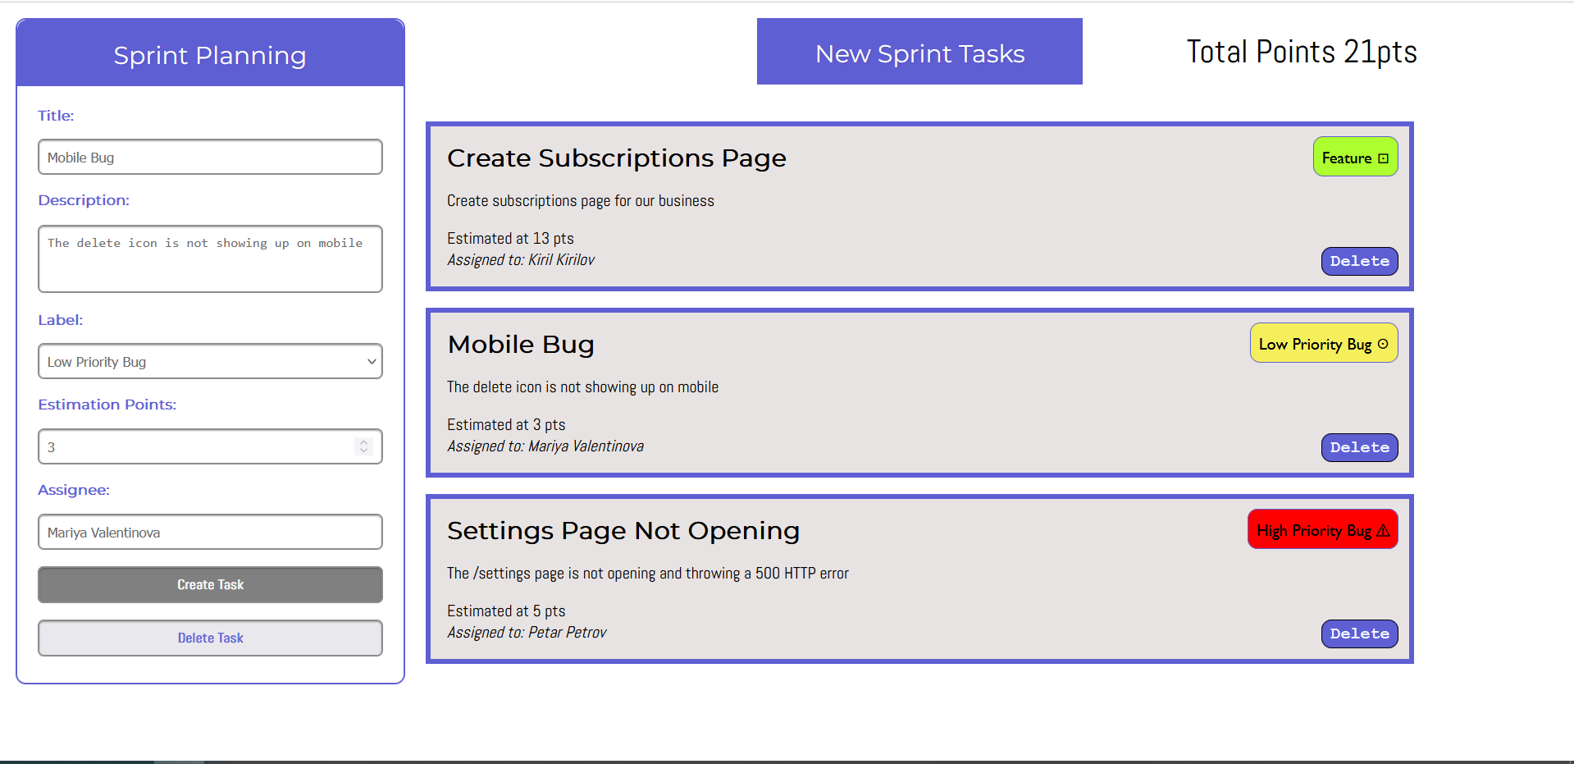

Delete a Task
- Clicking on the [Delete Task] button should remove the element from the DOM.
- Clear out all of the fields and enable them again after deleting.
- Enable the [Create Task] button and disable the [Delete Task] button.
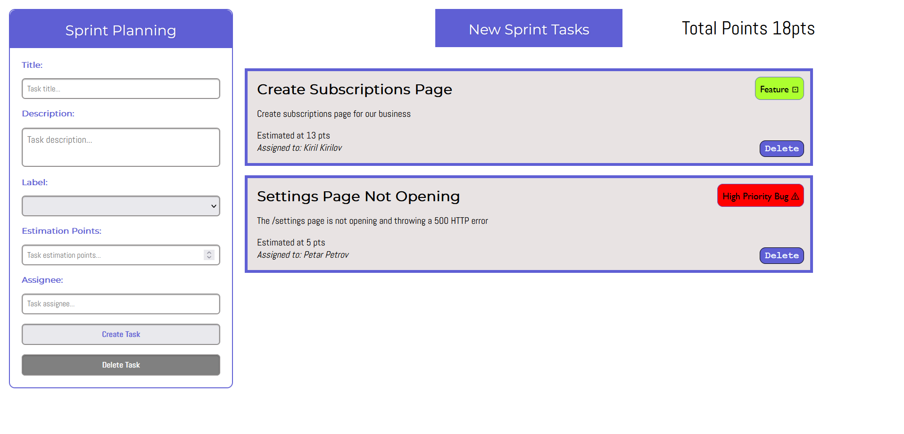

Total Points
- On the upper right corner of the page, there is a total points paragraph that needs to be updated.
- When creating a new task add the new estimation points to that counter.
- After successfully deleting a task from the form, subtract the estimation points of the deleted task from the total points.

Submission
Submit only your solve() function.

